Bookify Hotel – UI/UX Design Documentation (Classic Elegant Edition)

**Prepared by**: Eng. Ahmed Mohammed Mohammed Abdelrazek.  
**Course**: Full Stack .NET Web Development – Graduation Project.

•A professional and elegant hotel booking system designed with a classic beige and gold theme.

**________________________________________________**

# 1. Project Overview

•**Purpose:**  
To design a clean, elegant, and easy-to-use hotel booking system where customers can browse rooms, view details, and make reservations online.

**•Goals:**  
- Create an intuitive and visually appealing interface.  
- Implement a clear and professional layout using the N-Tier Architecture concept.  
- Provide administrators with tools to manage rooms and bookings.

**•Technologies Used**:  
- Figma (UI/UX Design)  
- ASP.NET Core MVC (for backend implementation)  
- HTML, CSS, jQuery (frontend structure for future development)

# 2. UX Flow (User Journey)

**•Customer Flow:**  
Home → Rooms → Room Details → Login/Register → Booking → Payment → Confirmation → Profile

**•Admin Flow:**  
Login → Dashboard → Manage Rooms → View Bookings

**•**This flow ensures users and admins can navigate smoothly and complete their tasks easily.

# 3. UI Design Pages (Screenshots Section)

## • Page – Home Page:

**-Purpose**: Introduce the hotel and provide easy navigation.

**-Design Notes**: Soft beige background with white and gold accents. Hero image with “Bookify Hotel” logo. “Explore Rooms” button.

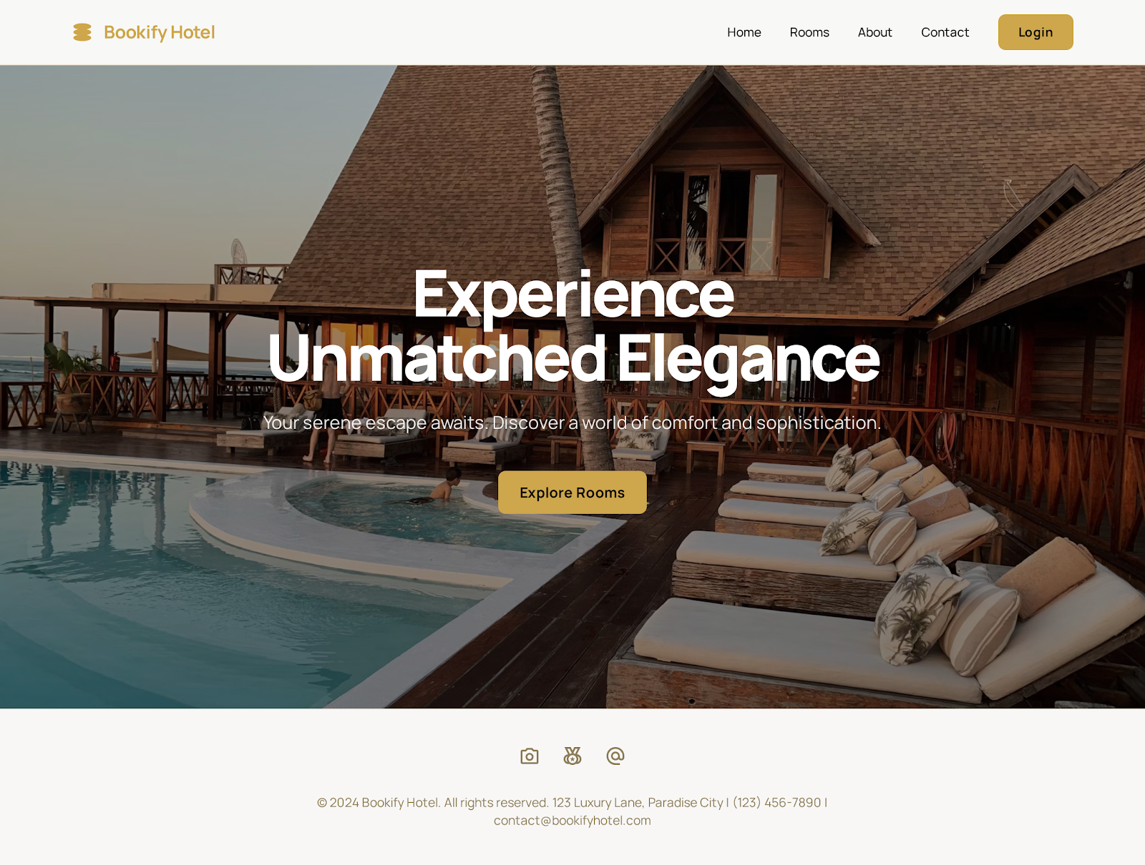

**________________________________________________**

## •Page – Rooms Listing:

**-Purpose**: Show all available rooms.

**-Design Notes**: Light cards showing room images, type, and price. Gold buttons “View Details.”

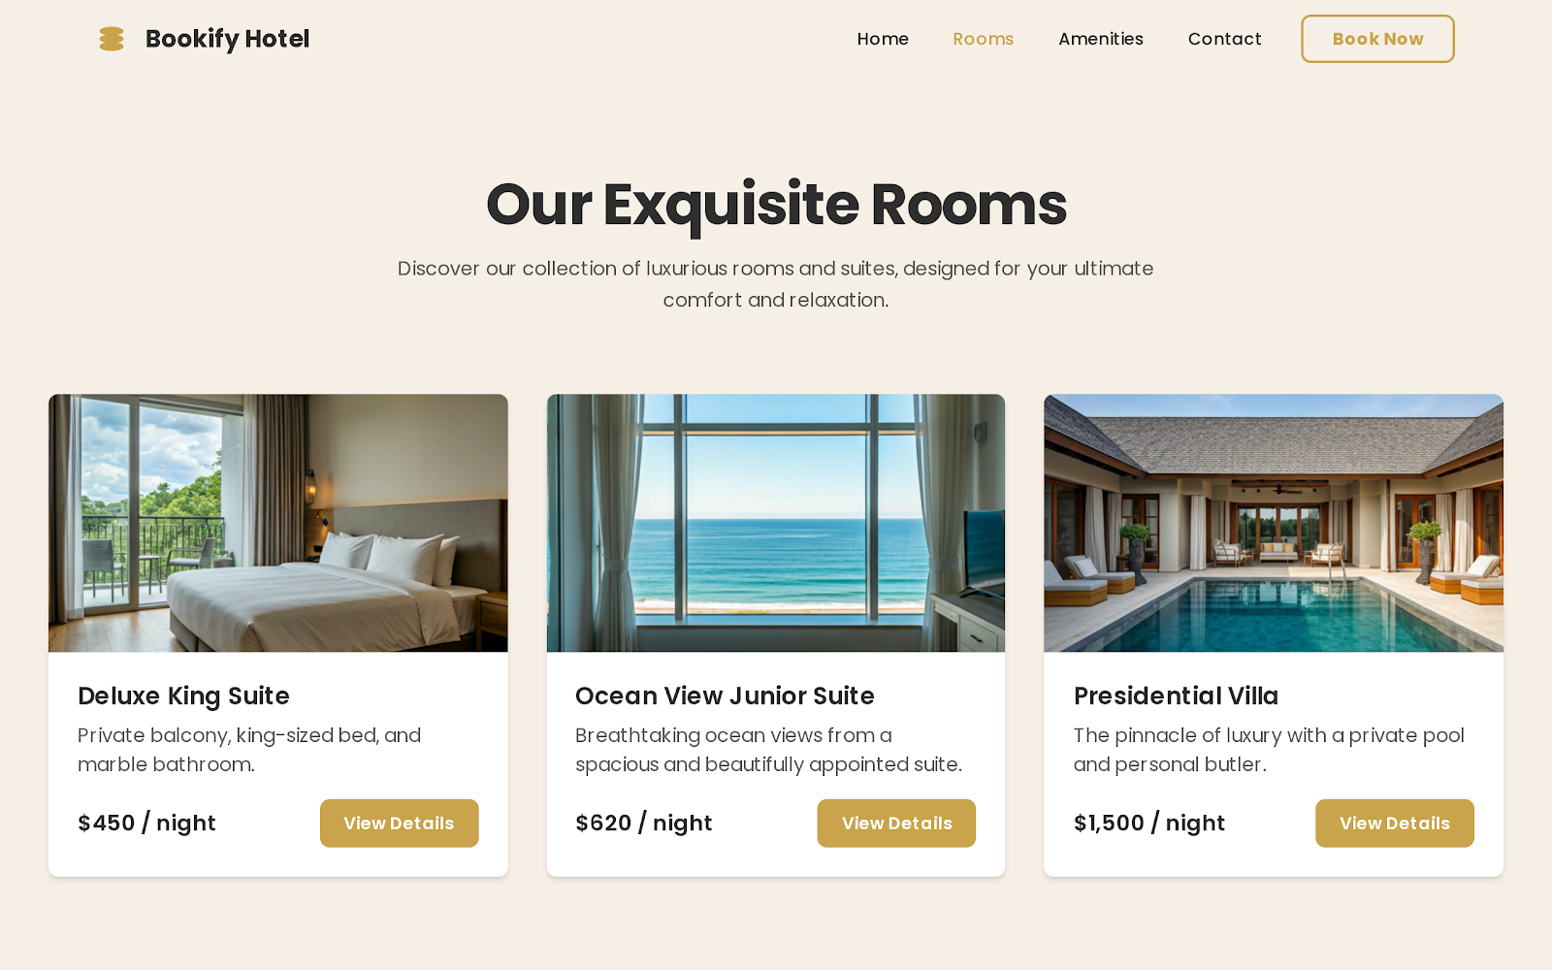

**________________________________________________**

## •Page – Room Details:

**-Purpose**: Present room info in detail.

**-Design Notes**: Elegant banner photo, gold headings, white background. Button: “Book Now.”

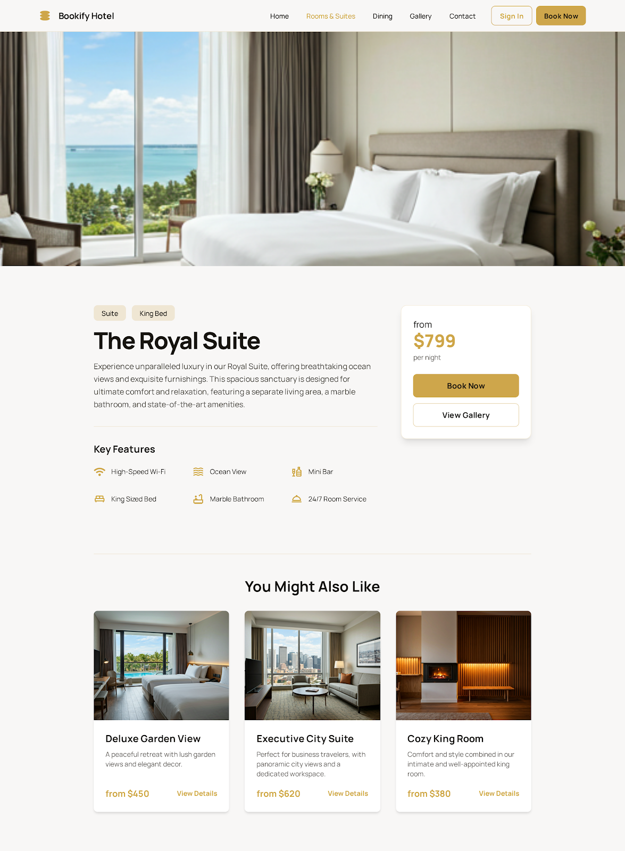

**________________________________________________**

## •Page – Login / Register:

**-Purpose**: User authentication.

**-Design Notes**: Clean layout, white background with gold highlights. “Login” and “Register” buttons styled in gold.

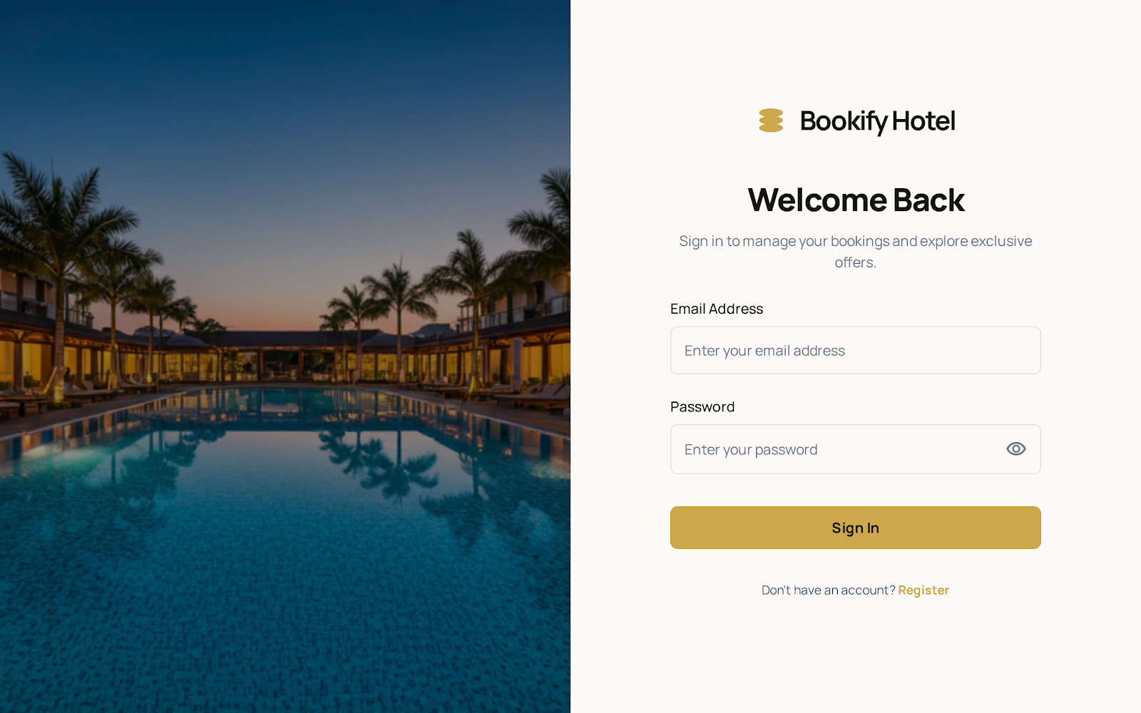

**________________________________________________**

## •Page – Booking & Payment:

**-Purpose**: Process booking and payment.

**-Design Notes**: White and beige layout, gold borders for fields. Payment form with “Pay Now” button.

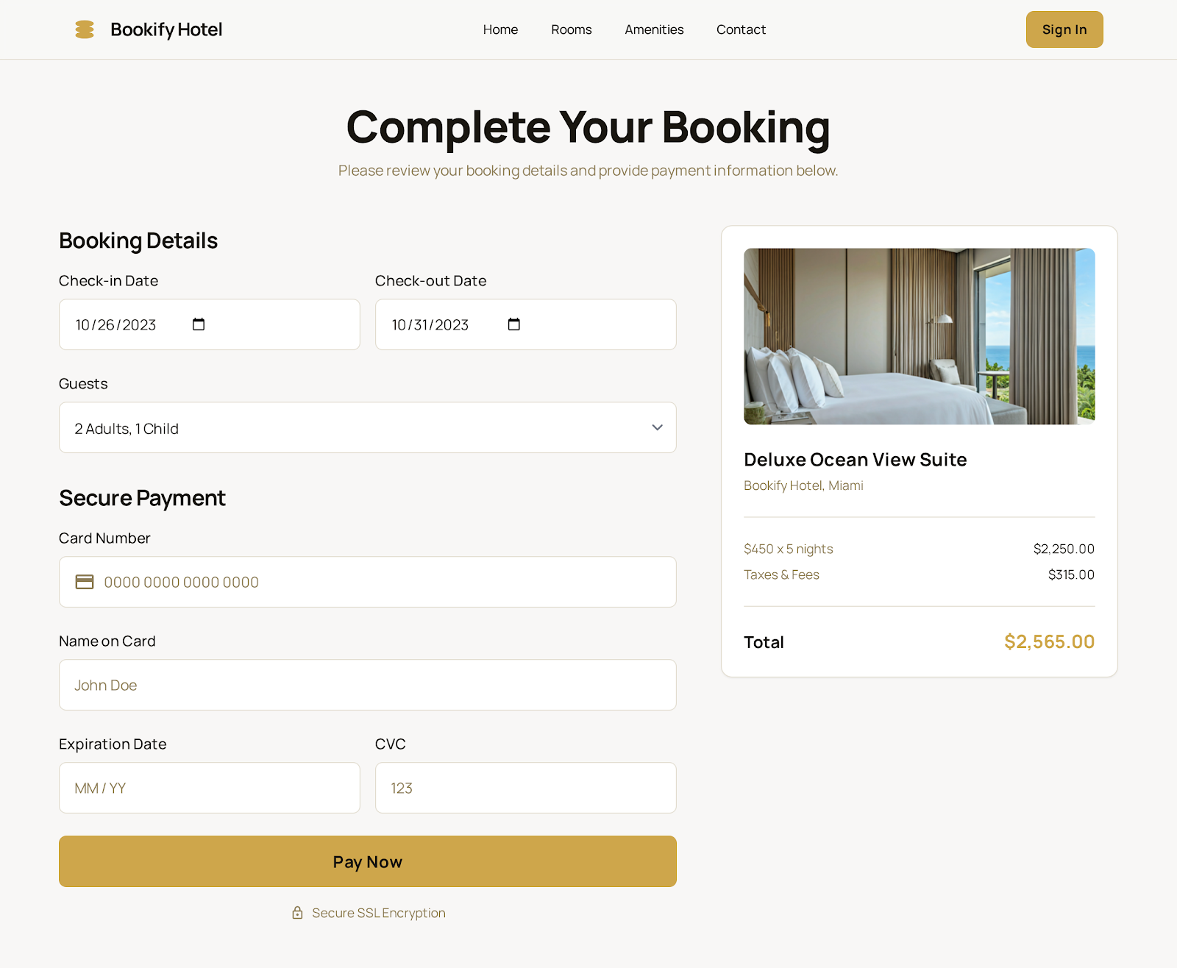

**________________________________________________**

## •Page – Booking Confirmation:

**-Purpose**: Show success message.

**-Design Notes**: Light background with gold checkmark and “Booking Confirmed!” text.

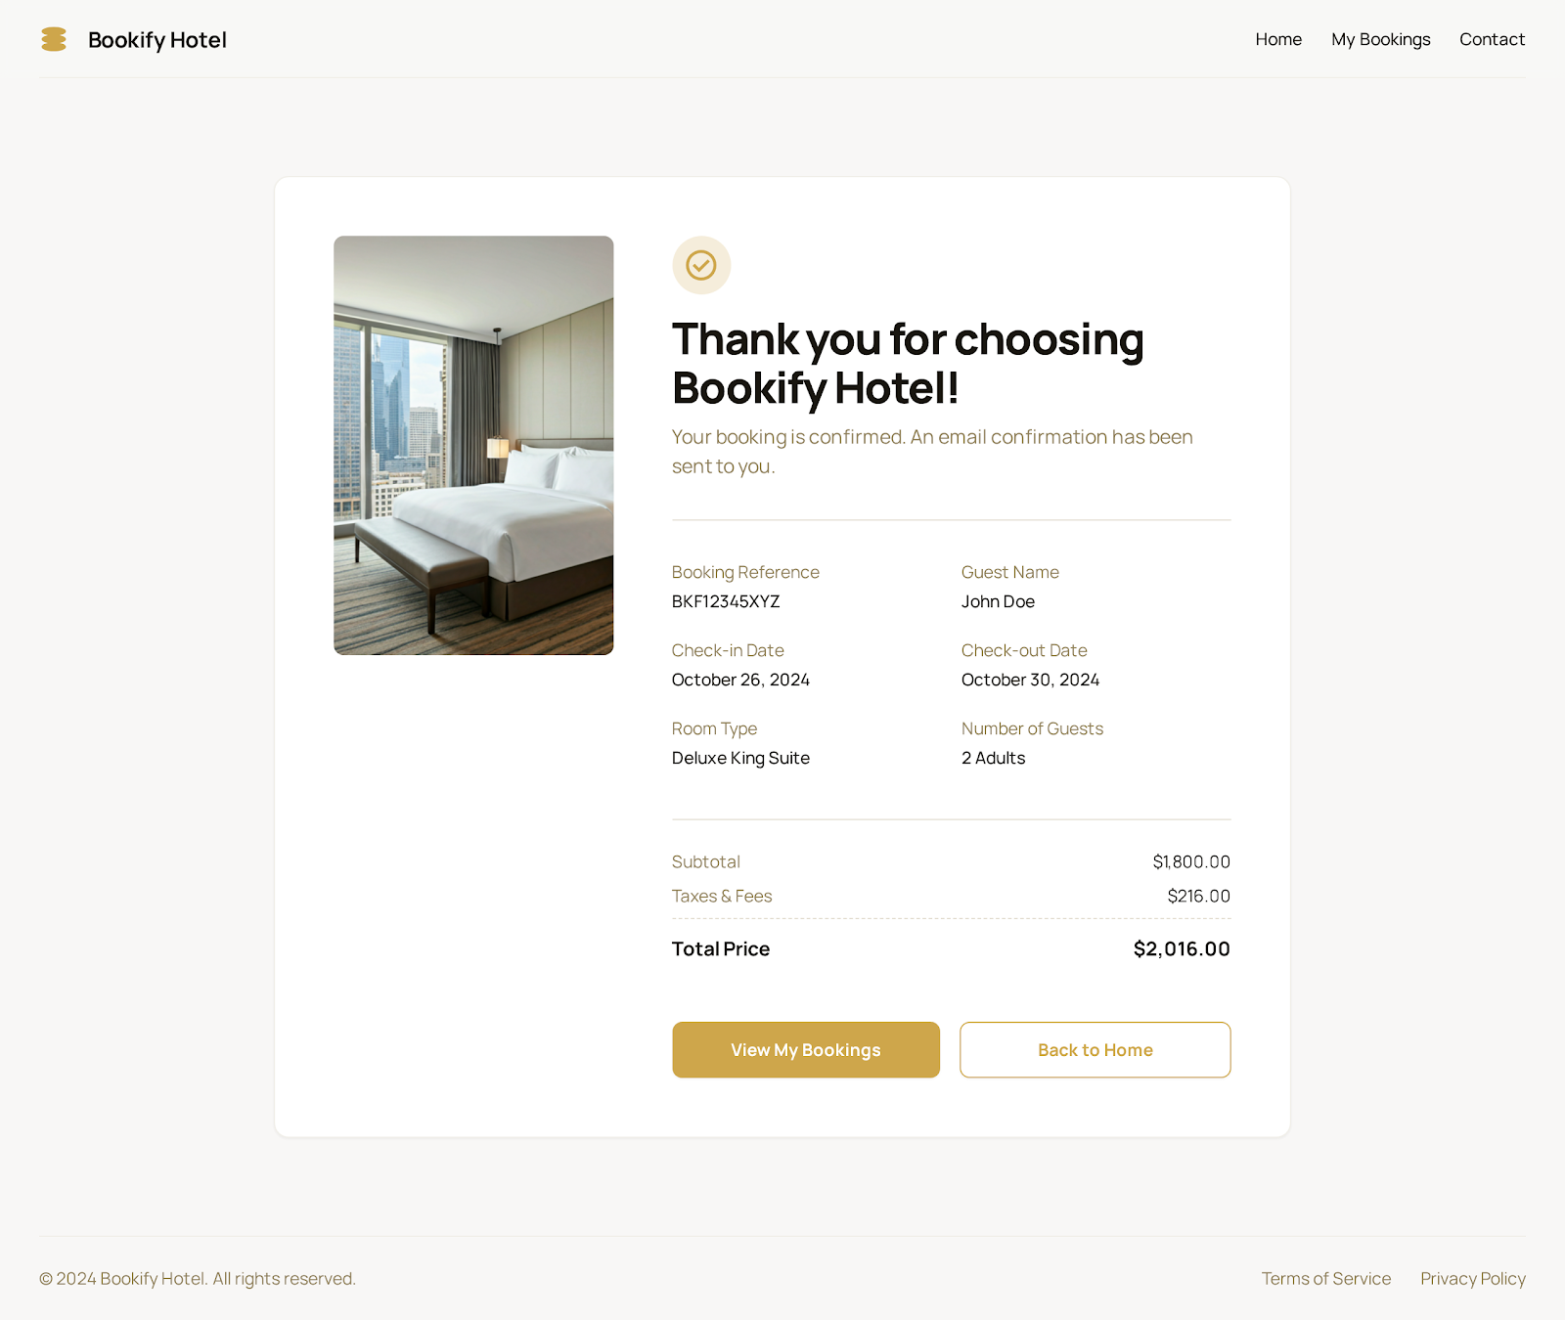

**________________________________________________**

## •Page – User Profile:

**-Purpose**: Display user info and booking history.

**-Design Notes**: White background with section headers in gold.

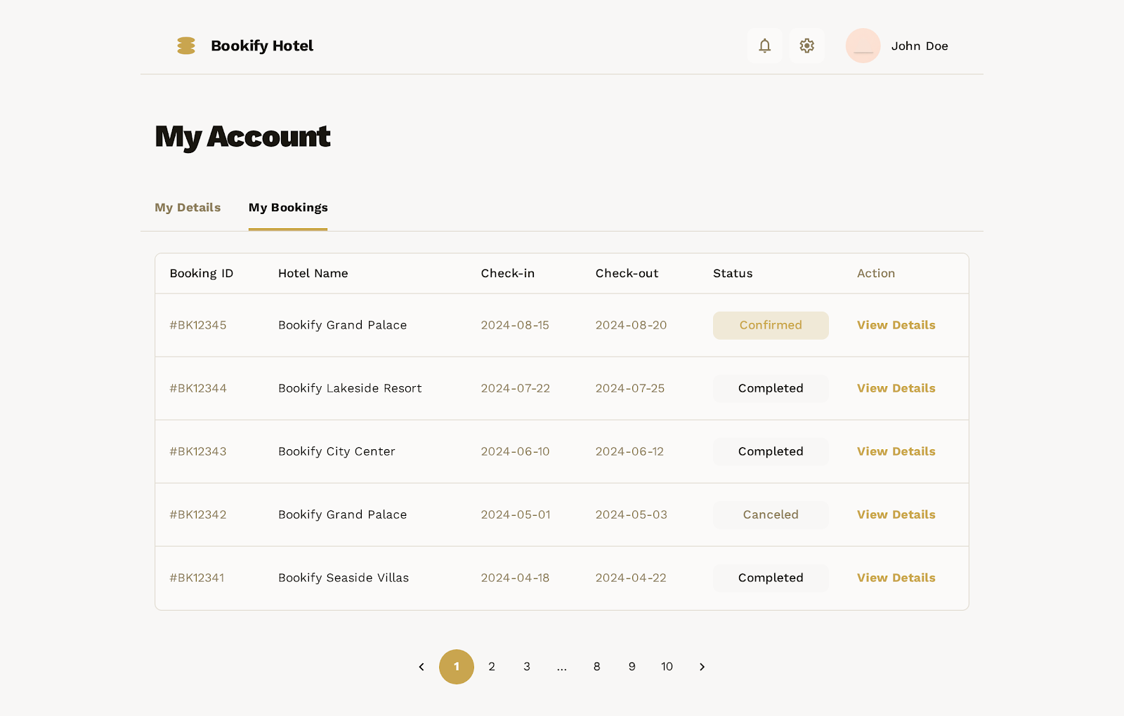

**________________________________________________**

## •Page – Admin Dashboard:

**-Purpose**: Show system overview for admin.

**-Design Notes**: Gold and gray elements, cards showing stats (rooms, bookings, users).

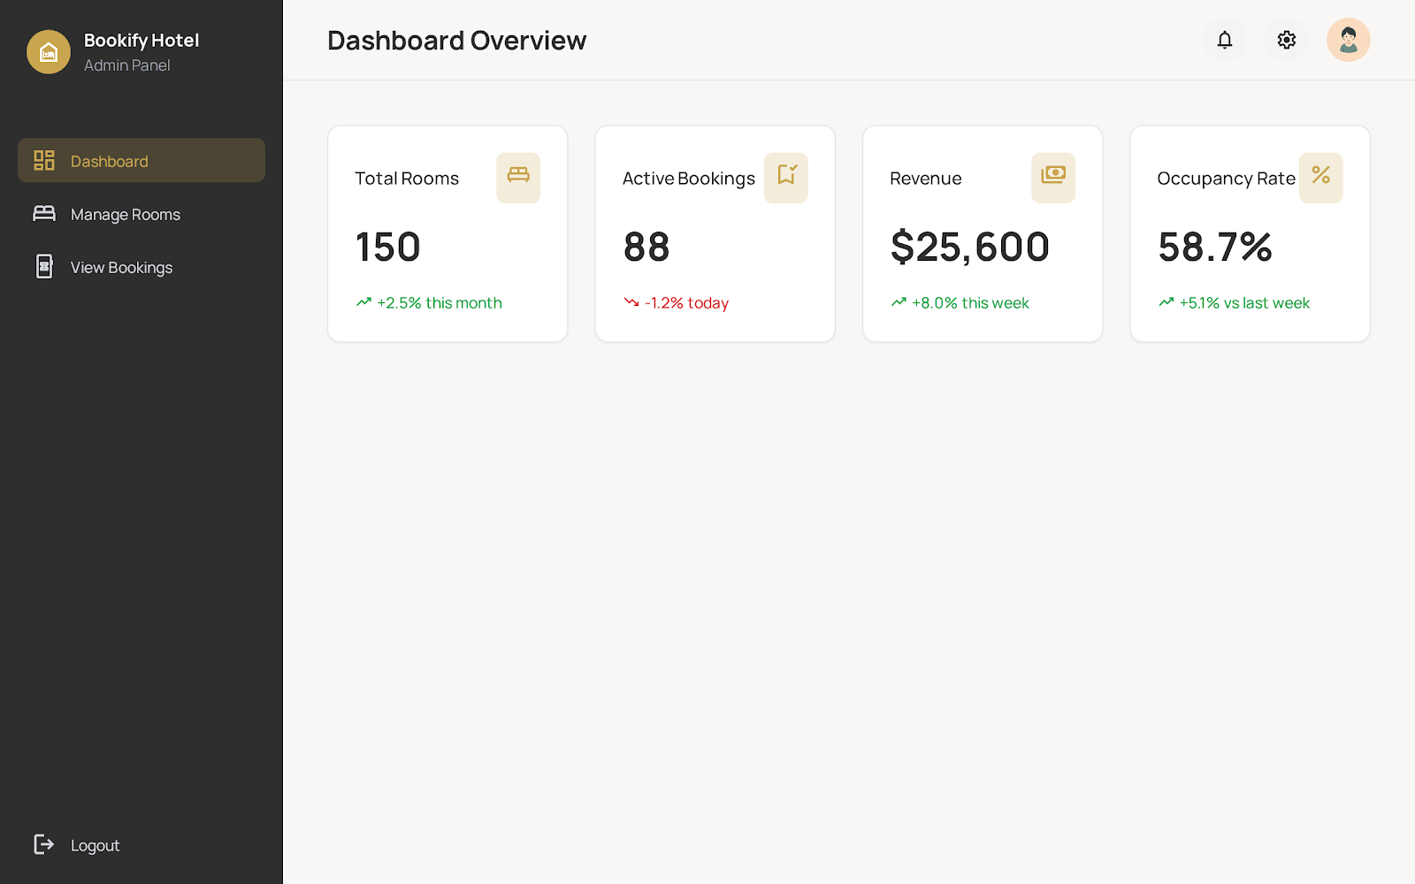

**________________________________________________**

## •Page – Manage Rooms:

**-Purpose**: CRUD operations for rooms.

**-Design Notes**: Table with beige rows, gold buttons for edit/delete.

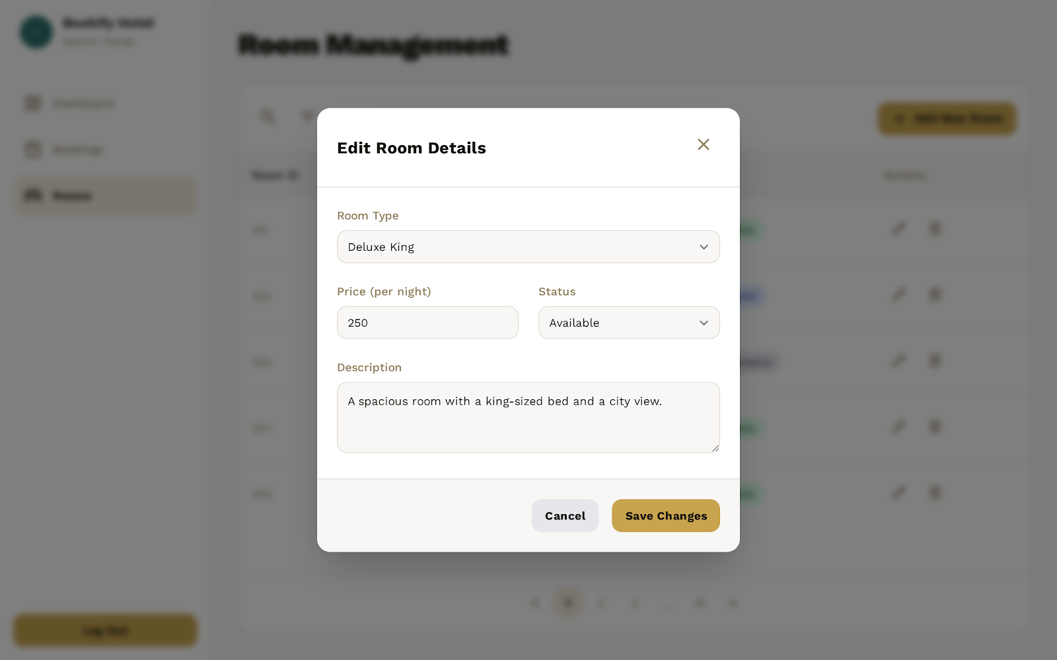

**________________________________________________**

## •Page – View Bookings:

**-Purpose**: Display all customer bookings.

**-Design Notes**: DataTable-style layout with search and filters.

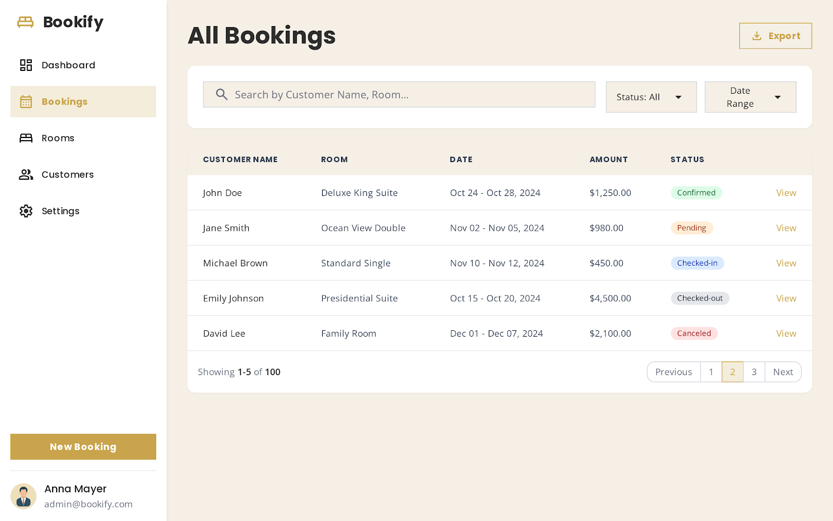

# 4. Color Palette & Typography

|  |  |  |
| --- | --- | --- |
| **Element** | **Color** | **Hex** |
| **Primary** | Gold | #C9A44D |
| **Background** | Beige | #F5EFE6 |
| **Text** | Dark Gray | #2E2E2E |
| **Accent** | White | #FFFFFF |

•Typography:  
- Playfair Display — for titles.  
- Open Sans — for body text.

# 5. Conclusion

The Bookify Hotel – Classic Edition UI/UX design delivers a calm, clean, and elegant interface that enhances usability and visual appeal. The structure and flow perfectly align with the graduation project requirements.